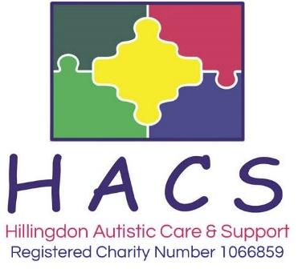
Workshop Booking form

I would like to request a place on the following workshop:

Workshop Title
Workshop Date & Time

Details of person attending:

Name
Contact Number
Address | (If you are a professional please use the address of your organisation)
Post code
Email
Circle your answer | I would like to be added to your mailing list: Yes / No
Special Requirements

If you require an invoice, please complete the following to who this should be sent
Name | Email
Please tick your chosen payment method
BACS payment  Sort Code 20-73-53 Account No. 63532836 Account Name: Hillingdon Autistic Care and Support.  Please quote your surname and workshop title as payment reference if you do not require an invoice | Cheques  Payable to Hillingdon Autistic Care & Support  Cheques posted are at owner’s risk  Cash  Deliver to: HACS, Dudley Place, Off Pinkwell Lane, Hayes, Middx UB3 1PB  Cash posted is at owner’s risk
For further enquiries please telephone: 0208 606 6780
Please email this form to catherine@hacs.org.uk
Or post this form to: Hillingdon Autistic Care and Support, Dudley Place, Hayes, UB3 1PB

